(Approx. 727 words)

Free Music with Freegal
By Tom Burt, Vice-President
Sun City Summerlin Computer Club
https://www.scscc.club
tomburt89134 (at) cox.net

One of my occasional Computer Club seminars touches on the many electronic resources available for free via the Las Vegas / Clark County library website. (One of those resources I briefly review is a service called Freegal (short for Free and legal). This article gives you an overview of Freegal, which has an extensive collection of music tracks and albums you can play. They also allow you to download up to 6 tracks per week for free. You might want to check to see if Freegal is available at your library.

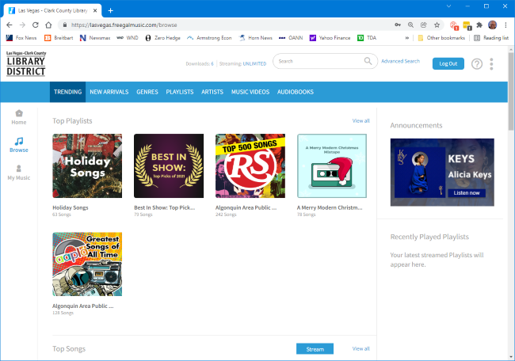

Reaching Freegal

You can reach Freegal from the Las Vegas / Clark County Library District website: https://lvccld.org/. Once there, click the Online Resources tab and then click Music. On the page that displays, click Freegal. A more direct way is to click the following hyperlink: https://lasvegas.freegalmusic.com/home.

You can browse the Freegal website without logging in, but you must log in with your library card number and pin to download any music tracks.

Navigating Freegal

Freegal claims it has 13 million songs and 40,000 music videos. Logged-in users may download six tracks a week for free and may stream music from the website for up to 3 hours per day. However, finding the material you’re looking for can be daunting.

The Home page displays featured playlists, songs, albums, music videos, and audiobooks. You can play any of these. Playlists and albums are collections of songs displayed in a list, so you can play or download specific tracks.

On the Browse page (see screenshot above), along the top are tabs for Trending, New Arrivals, Genres, Playlists, Artists, Music Videos, and Audio Books.

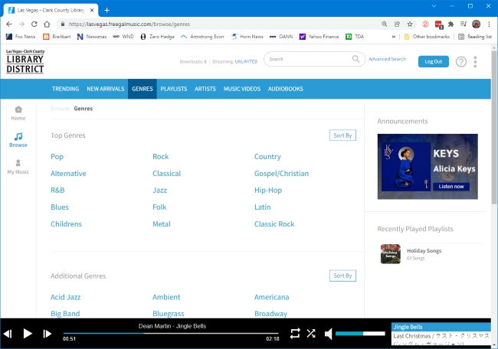

As an illustration, the Genres tab of the Browse page takes you to a listing of musical genres. You can click any genre to home in on the type of music you’re interested in.

Searching

If you are looking for a specific artist or song, you can use the search box at the top of the window. The search is quite intelligent. For example, I entered “Paul Simon” into the Search box and displayed a page of offerings, including some single tracks, a few albums, and music videos. Next, I chose an album called “Live in New York City” and then had a listing of all the tracks from that album, ready to play or download.

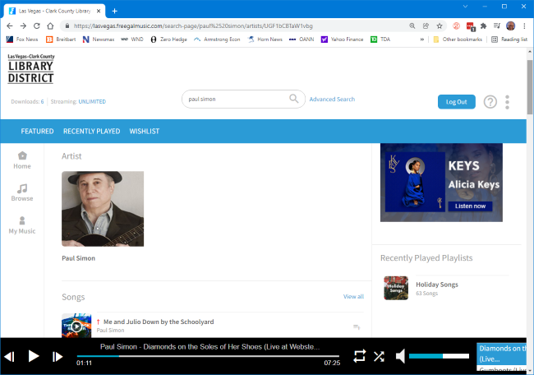

You can search for any artist, album name, or song title.

Downloading a Track

Click the down arrow when you’ve found a track you want to download and are logged in. The downloader will display a “save file/folder chooser” dialog. Select a folder to download the track into, click Save, and the file will then download. The file name combines the artist, album, track name, location, and date. In this case, it was: PaulSimon_LiveInNewYorkCity_50WaysToLeaveYourLover-LiveAtWebsterHallNewYorkCityJune2011_3.mp3.

You can edit this name in the save file dialog or later use File Explorer after the download is done. The file format is .mp3, and the sample rate is 256 kilobits.

Caveats

Many first-tier artists don’t allow all their work to be posted on Freegal. So all you can do is try the search and see what shows up.

A lot of the content is covered, by lesser artists, of original songs by first-tier performers. Some of this is quite good, and a lot is fairly mediocre. Beware also of “remixes.” These are cases where someone has taken an original song or album and digitally manipulated the background music. These are usually not as appealing as the original artist’s recording.

Final Thoughts

Freegal can be a great place to find oldies in high-quality mp3 format. I use it mainly for that. Much of my personal music collection was “ripped” from LP albums or audio tapes at 128 Kilobit sample rates. The digital recordings have pops and hisses and weak treble. If I can find those tracks on Freegal, I download them to replace my original low-quality recordings.

You can get some pleasant surprises. For example, I enjoyed a lot of Peter, Paul, and Mary, the Limeliters, and the Kingston Trio – all folk groups back in college.

At six songs per week, if you’re organized and committed, you can collect 312 songs per year. After a while, that starts to add up. And you can’t beat the price.

